Docker Container Deployment

Purpose
In this exercise we demonstrate that we take the current local DHBW Home Page into the Cloud using a Kubernetes Docker Container environment.. For that we will use Juergen's IBM Bluemix Account and in in that account we will user an existing Kubernetes Cluster mycluster with a Pod and deploy our Web Pages.

The Container approach (Docker, Kubernetes has an explicit BUILD/PUSH and RUN step we need to configure.

Build a local docker Image from your local deployment
Take a terminal session and go to your working directory juergenschneider/dhbwcloud/kubernetes
Log into Bluemix BX
login bx -a https://api.eu-de/bluemix.net
Set the context for the cluster used (mycluster has been deployed already in Bluemix)
bx cs cluster-config mycluster
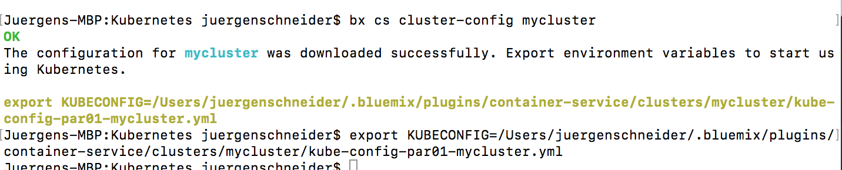
Test the setup using
kubectl version –short

Repeat above steps in a second terminal session in order to allow to set up a Kubectl UI session using a proxy. For starting the proxy you need to enter
kubectl proxy

Now we need to start the Docker Terminal using the Mac Docker Toolkit. After the start, again test the Docker version in the first terminal using
docker --version
Now we are ready to build a docker image (locally) using the following docker command
docker build -t registry.eu-de.bluemix.net/juergenschneiderspace/dhbwmac1 .
Don't forget the . This tells docker to use the current directory with -t we tag the docker image with the name (of the registry adn namespace and the name of the image.

Let's have a closer look to the docker file which define the build process
This file is basically a set of instruction to build the content of your local image
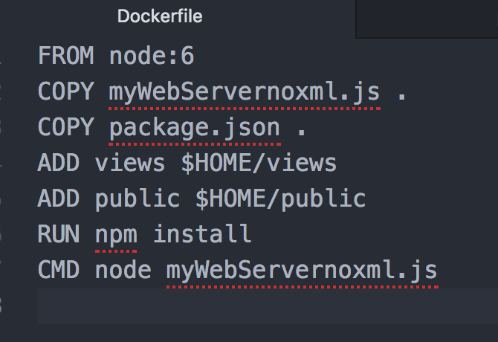
Briefly..
- the FROM command describes the base image which in our case is a Linux system with a node and NPM environment. We typically use a standard cloud offering for this.
- With the two COPY statements we copy the two file (the start JS file and the NPM Package.JSON) to the $Home directory of the image
- With the ADD statement we are adding the two new directories to the image and copy the content of the views and public local directory to the image. The way this works is a bit tricky and requires a extra exercise.
- After that we run the NPM install to get all the plugins
- and we define the start command which is a node command using our server w/o the xml feature
The NPM package file looks very similar to the package file we used in Cloud Foundry as this actually define the node.js content and has nothing to do with the deployment target.

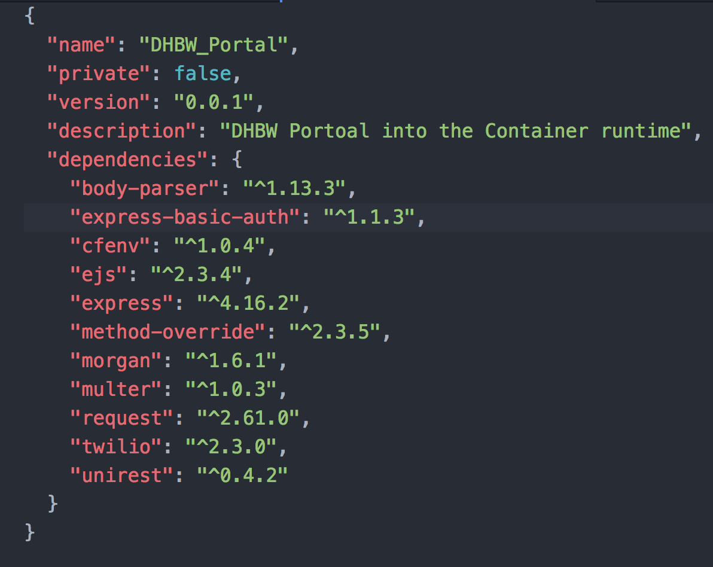
Now let's run the build command
- docker build -t registry.eu-de.bluemix.net/juergenschneiderspace/dhbwmac1 .
And the output will be something like...
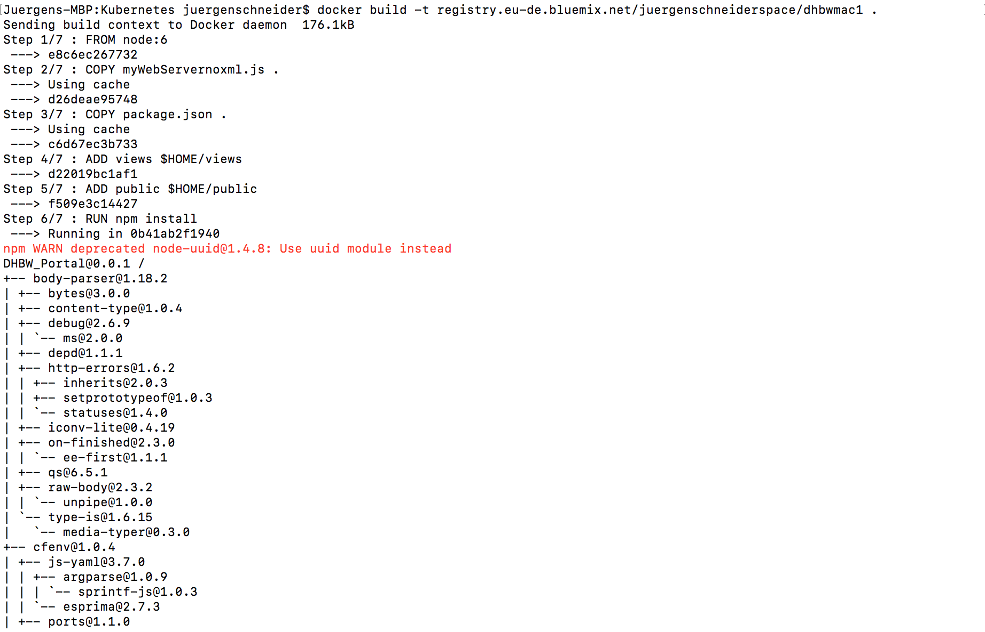
we see the copy and add command from the docker fil and the NPM Install output. If we are lucky the command will end with something like this.
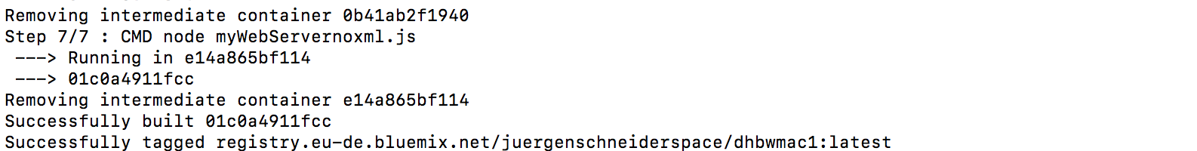

Push the local Docker Image to a Cloud Container Registry
In order to start this process I need to login to my cluster registry services I have booked in Bluemix. The Container registry is part of Juergen's Container Services and will mostly be used via the command line interface.
- bx cr login
- bx cr namespace-list
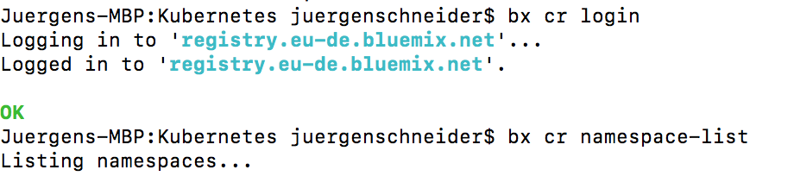
The namespace has been created in an earlier command and must correspond to namespace tags for the image and is also used in the following push command.
- bx cr namespace-add juergenschneiderspace
And here comes the PUSH command
- docker push registry.eu-de.bluemix.net/juergenschneiderspace/dhbwmac1
we specify the the tagged local image which is the name of our cloud container registry and name the image like dhbwmac1.
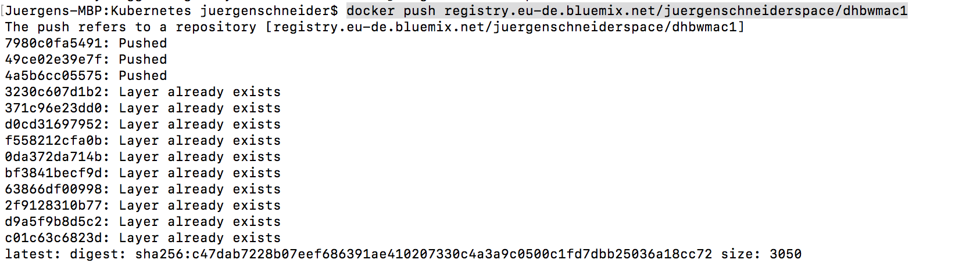

Deploy the image into the container and expose it as external accessible service
This step will be executed via the kubectl command. As we have a proxy activated earlier we can also access the Kubernetes UI
http://localhost:8001/api/v1/namespaces/kube-system/services/kubernetes-dashboard/proxy/#!/pod?namespace=default
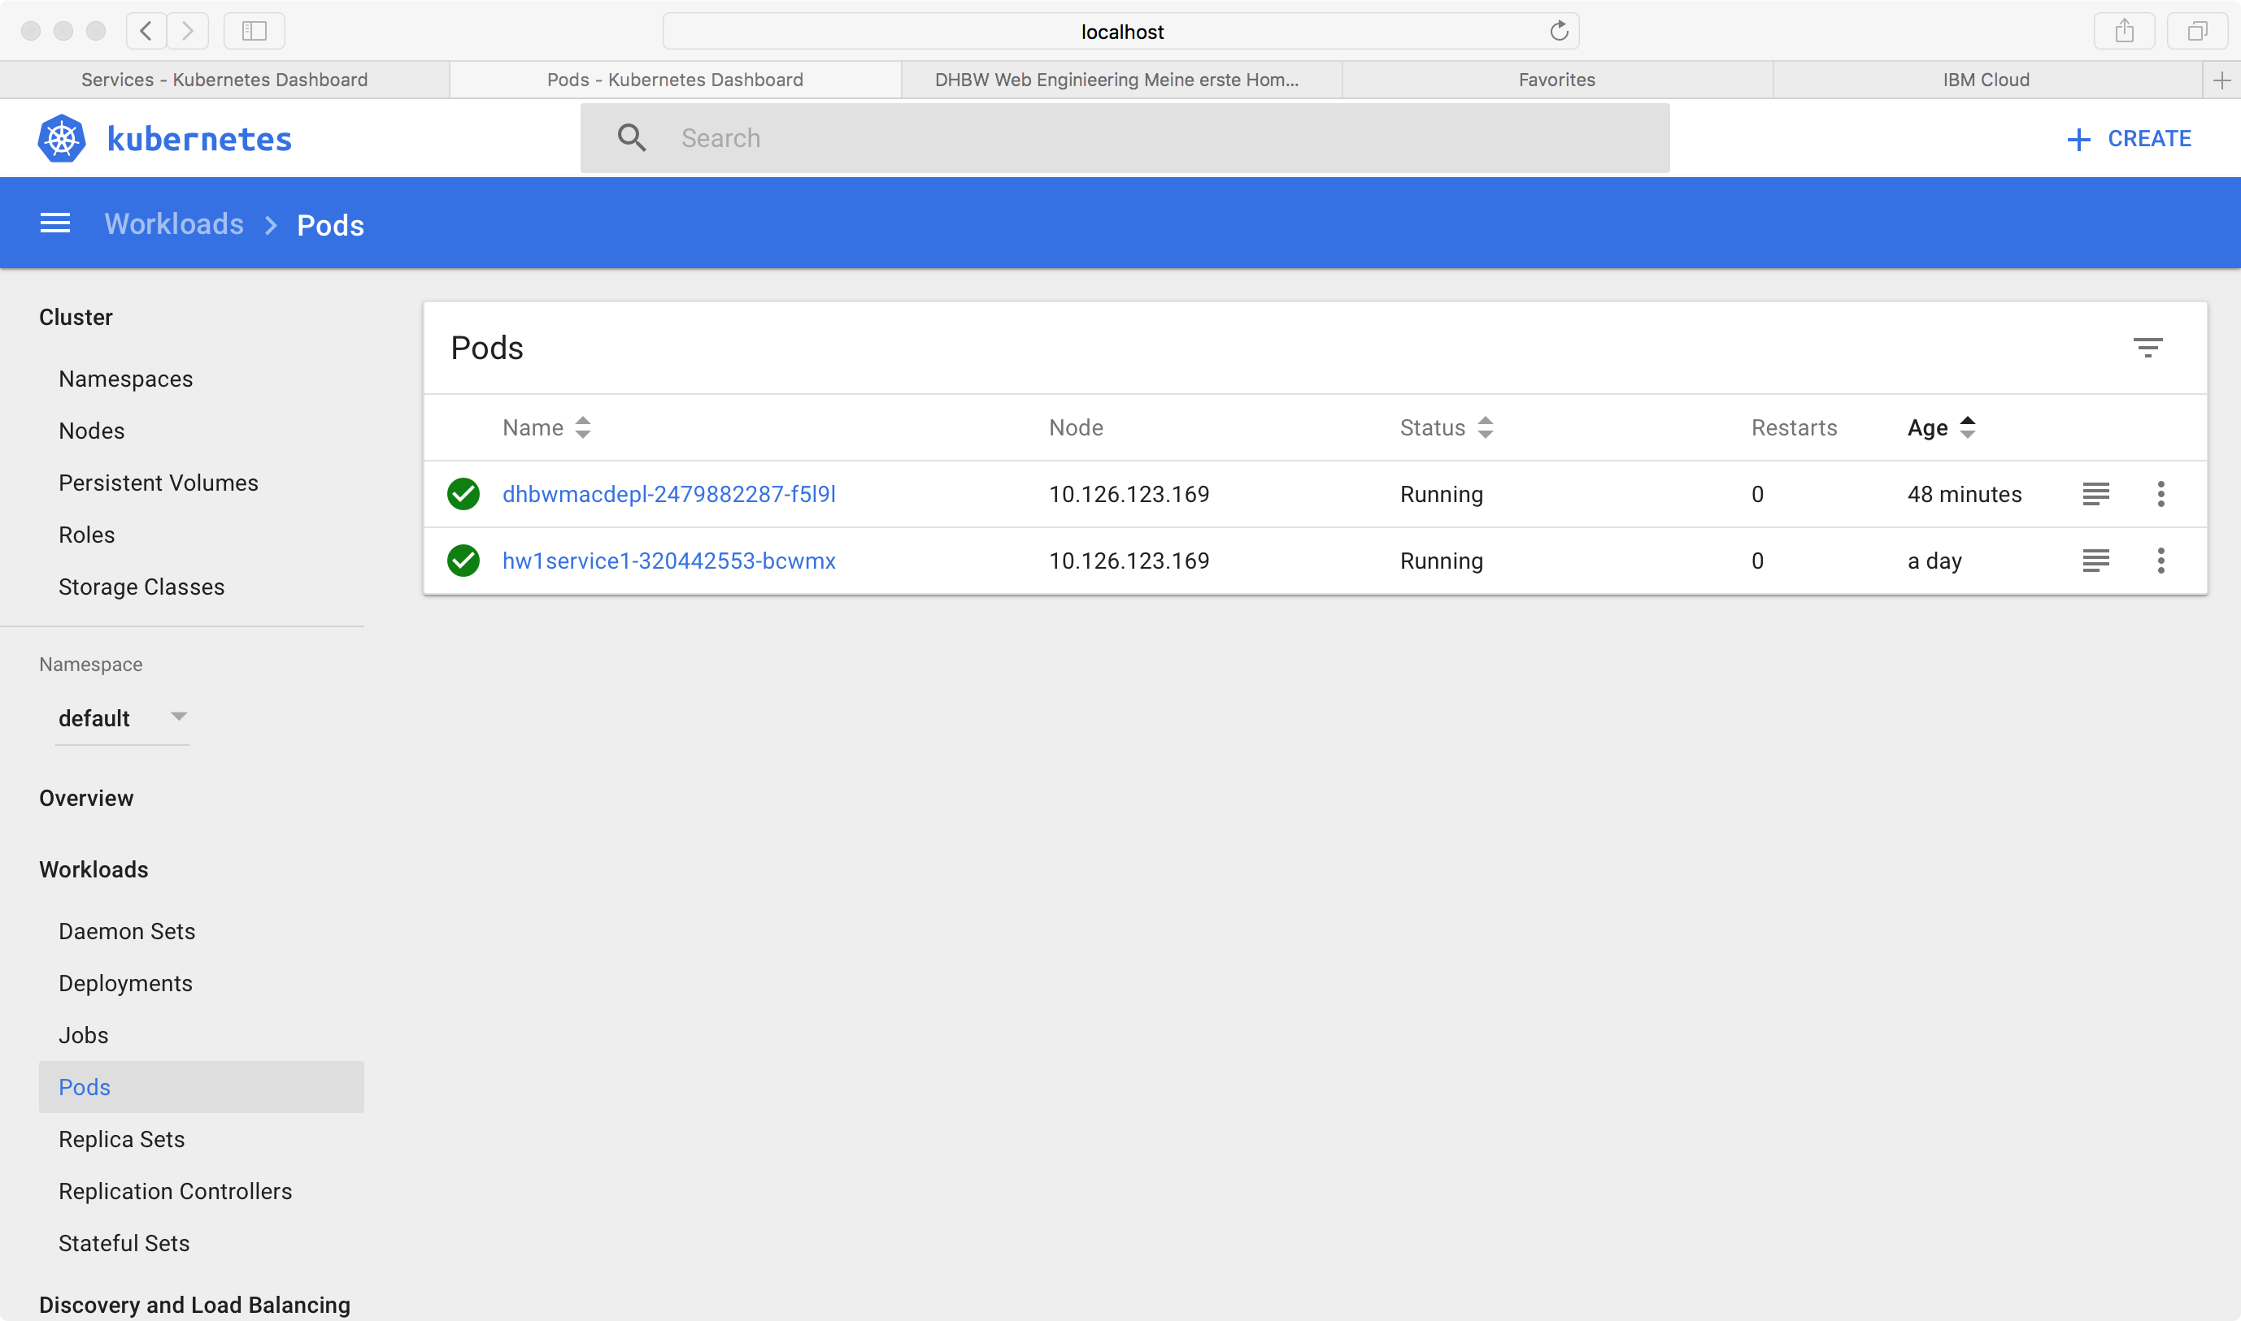
The command to deploy a image into a Kubernetes Container is:
- kubectl run dhbwmacdepl –image=registry.eu-de.bluemix.net/juergenschneiderspace/dhbwmac1
returning something like deployment "dhbwmacdepl" created. dhbwmacdepl become the name of the deployment. We can use the UI to see the logs
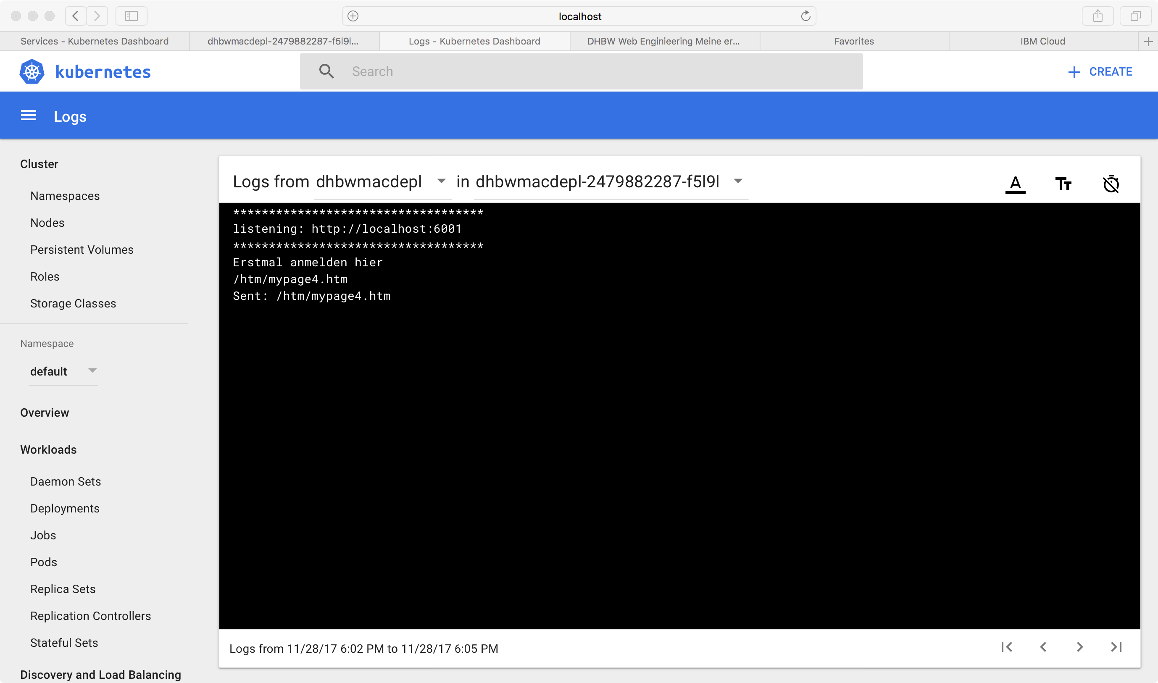
As we see the node app has been started and is telling us that the node.js is listening to port 6001.
The next step is to expose the running deployment as service.
- kubectl expose deployment/dhbwmacdepl --type=NodePort --port=6001 --name=dhbwservice –target-port=6001

the name of the service in this case is dhbwservice and the port 6001 is no mapped to ta node port type. ( we are not going into more detail here).

- kubectl describe service dhbwservice
The result is something like:
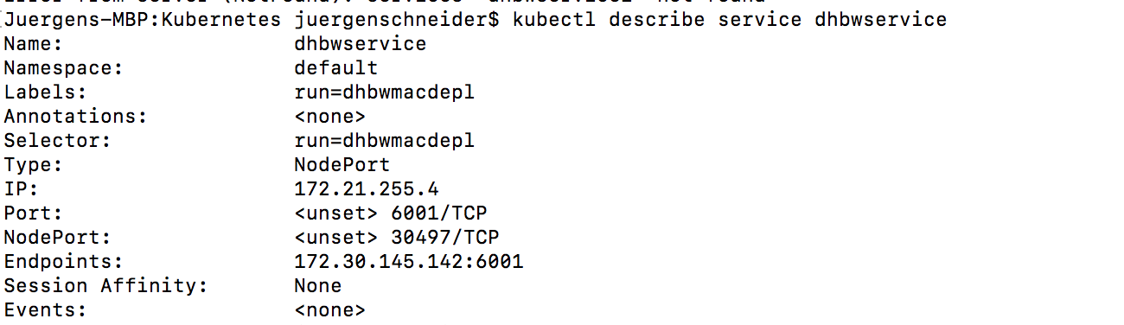
Now take the nodeport 30497 and the IP address of the worker node to build the URL.
The worknode IP can be obtained using the following command.
- bx cs workers mycluster

and the following output

The URL is now http://169.51.17.70:30497/....



